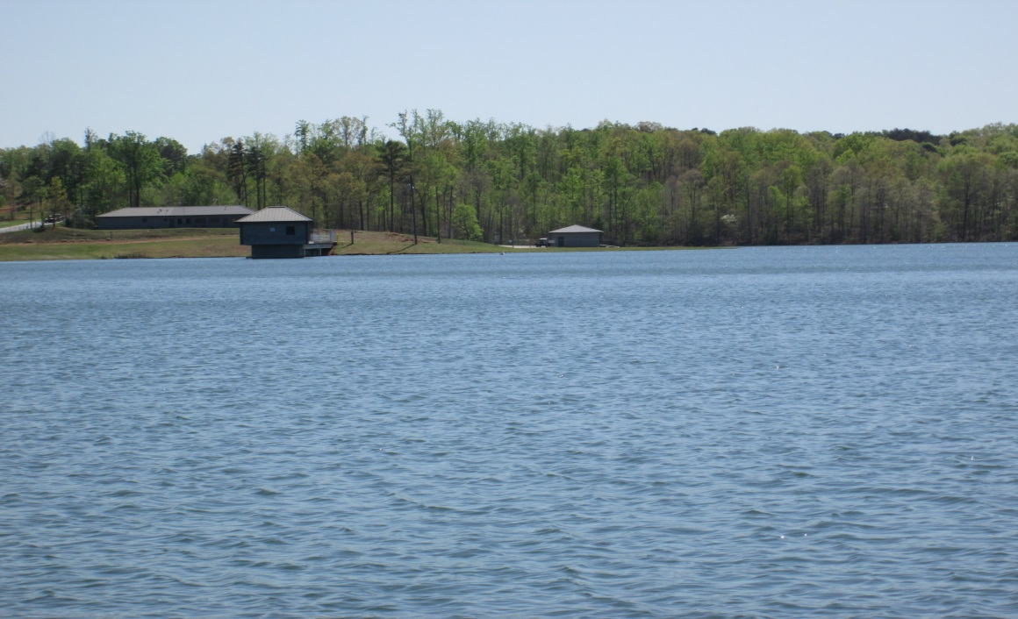

The Reservoir entrance is located at 5436 Cowart road Dawsonville, Ga. 30534. The Reservoir encompasses 334 acres with about 15 miles of shoreline and is surrounded by 150 foot buffer. The lake is located in Cherokee and Dawson Counties. In 2000 the Reservoir was stocked with Blue Gill, Shell Cracker, Largemouth bass, and Channel catfish. Other species of fish are present, which include, Spotted bass, Redeye, Speckled catfish, and Crappie which were not part of the initial stocking program. There is only one public access with a boat ramp and paved parking, a daily use fee of five (5) dollars per vehicle, with on site pay box and instructions. The Reservoir is open to the public year round, except Christmas and New Years Day. Inclement weather can cause closures that are not posted. This is a gated access, with opening and closing performed by CCWSA personnel. CCWSA ask that all participants practice water safety and help keep the property clean to insure continued public use. State regulations and rules apply to all whom use the Reservoir. DNR officers and CCWSA personnel, patrol the lake to encourage water safety.
RULES HISTORY LAKE HOURS:
WATER LEVEL and SURAFCE TEMPTURE 8 A.M. – 8 P.M. From Memorial Day to Labor Day [Summer Hours]
PICTURES Special Notice 8 A.M. – 5 P.M. From Labor Day to Memorial Day [Winter Hours]
Reservoir Office open Monday – Friday during above times.
(*Times subject to change)
A yearly Pass can be purchased at the Reservoir office for $50.00 dollars, check or cash.
Office phone 770-894-4356

